**Project Name:** Quiz Application

**Github Link:** https://github.com/projectsforstudents2022/Quiz_Application.git

**Why was this project created?**

The "Quiz Application" is a collection of numerous different quizzes, including sports, gaming, and technical quizzes. The complete quiz can be accessed/played, and any of the questions can be tried. There will be a set amount of questions, and users will receive credit scores for each accurate response. The user has the option to ask a question and view the associated answers.

**What problem is it solving?**

The major goal of the "Quiz Application" is to facilitate an environment that is user-friendly for all users and minimize manual labor. In the past, quizzes were administered manually, but as technology has advanced, we are now able to produce scores and present questions automatically. The functional requirements include creating users who will take the quiz, generating quiz results automatically, adding, deleting, and updating users with admin privileges. The administrator controls all rights in this programme.

**Entire explanation of project**

* **PROPOSED APPROACH**

First, we must create interfaces for the user's profile as well as the Home Page, Login Page, Questions Attempting Forum, and Result Page. Each of these pages is connected to the server and database.

in order for it to function properly. There are websites today that simply offer a small selection of quizzes relating to various topics. Many websites lack a centralised platform for quizzes on technical, general knowledge, aptitude, games, etc. Additionally, there isn't a website where people may post queries and answers for other users to see. We must create a programme that can solve each of the aforementioned issues. By using this, a person can learn new things, get answers to their questions, and share their knowledge with others.

* **RESULT**

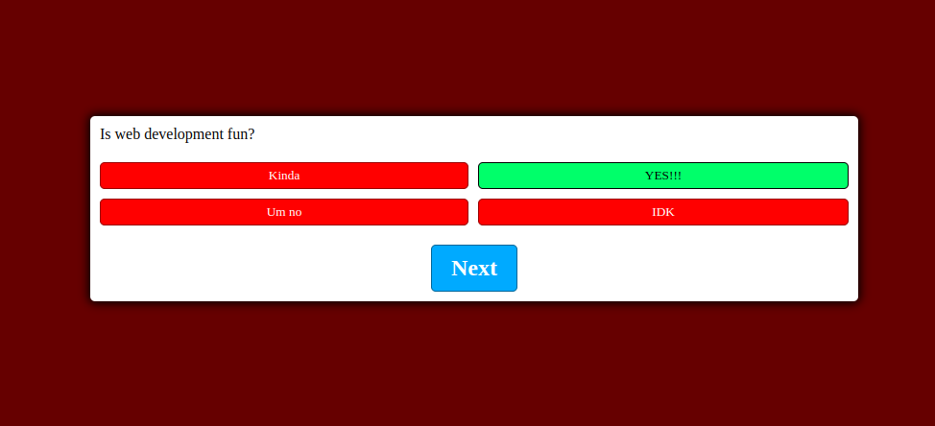

**CONCLUSION**

The ability to take quizzes anytime and anywhere is provided by the quiz application. The ability to include as many questions as possible in a particular quiz is granted to the administrator. For the quiz, users can sign up and log in. If a user forgets their password, they can reset it using the Forgot Password option. Students can find information regarding the quiz, such as the amount of questions and the allotted time, on the instruction page. Student then receives quiz results. Students cannot wait for the outcome. The admin is also in charge of adding, deleting, and updating questions in the database. He may also see the results of all the students.